Instrument Calibration – Lab 4:

Date Performed: 03/15/2023

Lab Instructor’s name: Mark Vanpoppelen

**Honor Statement:**

An essential feature of the University of Tennessee, Knoxville, is a commitment to maintaining an atmosphere of intellectual integrity and academic honesty. As a student of the university, I pledge that I will neither knowingly give nor receive any inappropriate assistance in academic work, thus affirming my own personal commitment to honor and integrity.

I understand that inappropriate assistance includes:

* Using past lab data
* Using lab data from another section (unless approved by your instructor)
* Using the text from past lab reports
* Using text from another student’s lab report

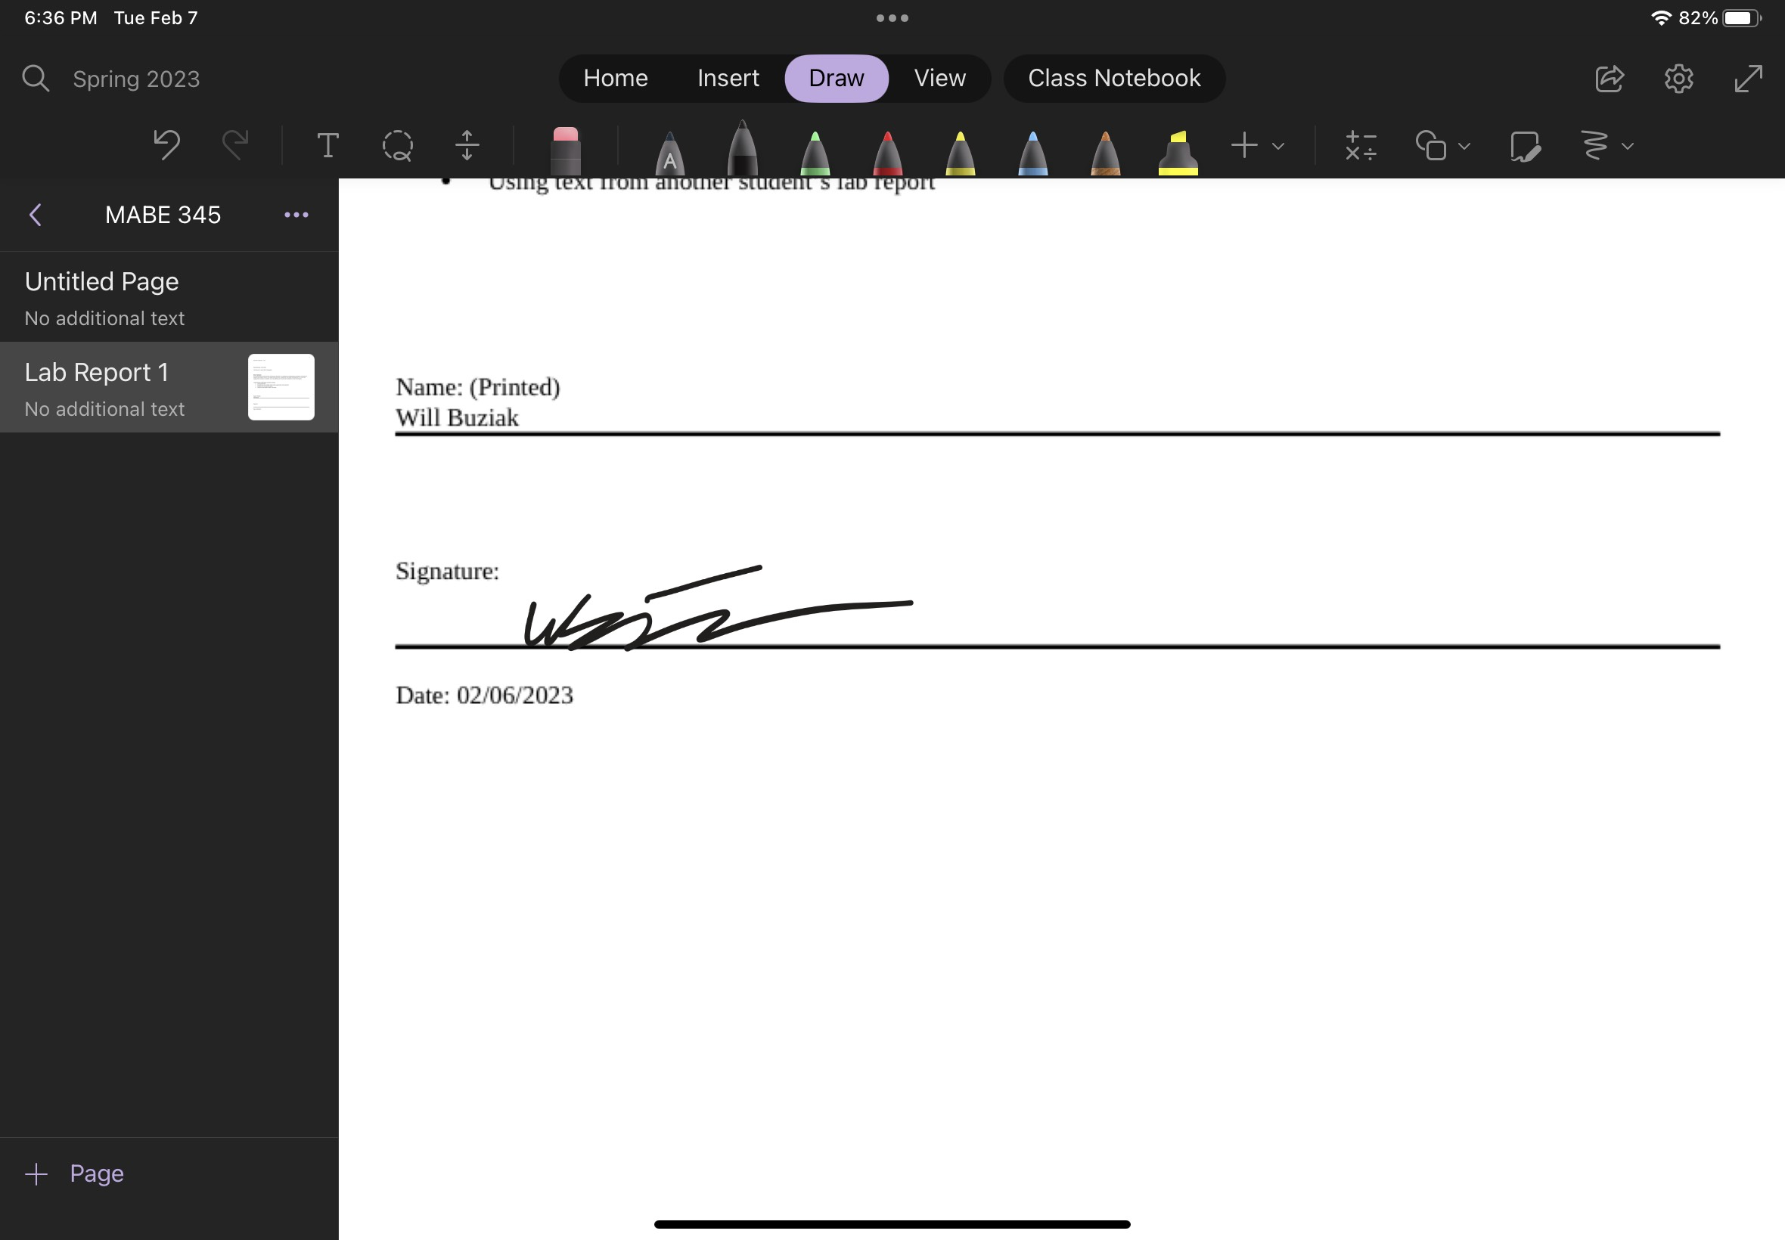

# ABSTRACT

*Will Buziak*

*(Dept. of Mechanical, Aerospace and Biomedical Engineering, University of Tennessee, Knoxville)*

Lab Report #4 – Second Order Systems

This lab was the student’s first true interaction with physical oscillation. After learning the principles of system dynamics and understanding how to measure, interpret and manipulate frequencies and signals, the same tactics can be applied to larger, more physical systems. Before, the students studied signal frequencies and understood their properties and many tools to dissect said frequencies. But, what about when those behaviors are displayed by physical objects and motion? What about predicting future behavior or deriving information about what is observed? In the Second Order Systems lab, students got an in depth introduction to measuring the oscillatory motion of a spring system and using system dynamics principles to understand the physical properties that define the system’s behavior towards a steady state solution.

# INTRODUCTION

The students are expected to walk through two experiments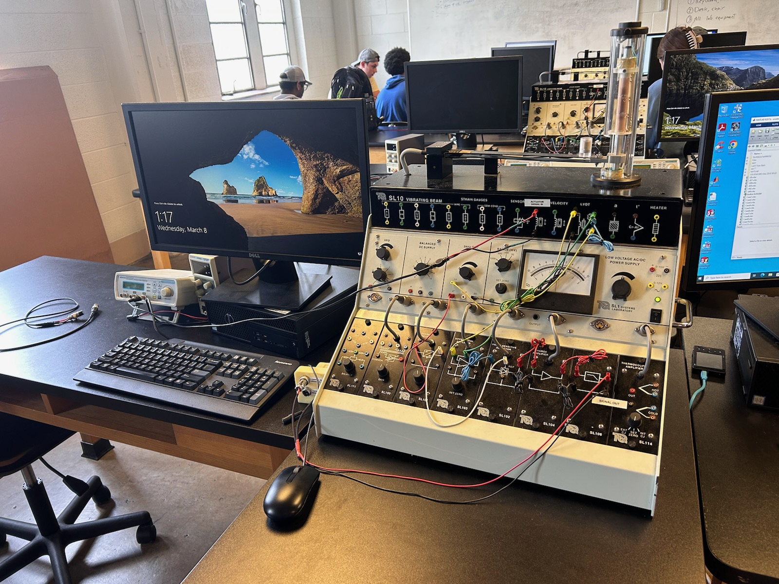 utilizing the oscilloscope to measure the motion of the LVDT after an initial load was imparted to produce oscillations. Using the oscilloscope, the students will measure the voltage relationship to the linear and temporal displacement of the LVDT. Using these readings, the students will be able to extrapolate the damping ratio and natural frequency of the

Figure 1

Initial setup

system. In experiment 2, the

students are tasked with

determining the response of

the system due to different vibration frequencies. After comparing the collected data with an expected calculated theoretical magnitude ratio, the student will be able to extrapolate relationships between damping ratios and steady state responses.

## Theory

One can notice a few stages of behavior that a system goes through in the aftermath of an input force (or voltage). Being able to identify, understand and predict the behavior in each of these stages is a key skill for engineers working with frequencies or oscillations/vibrations. Thankfully, system dynamics has a plethora of tools to break down each stage of the system’s journey to steady state behavior. By analyzing the measured behavior of a system, one can then extrapolate data regarding the system’s inherent properties. Among the many desirable traits that an engineer would be tasked with unveiling, it is a frequent occurance that the damping ratio and natural frequencies are necessary parameters to know when designing both static and dynamic structures. A simple breakdown of the different stages of oscillatory motion with damping are the rising, settling, ringing and steady state stages all defined by the system’s second order differential equation which describes it’s behavior.

## Procedure

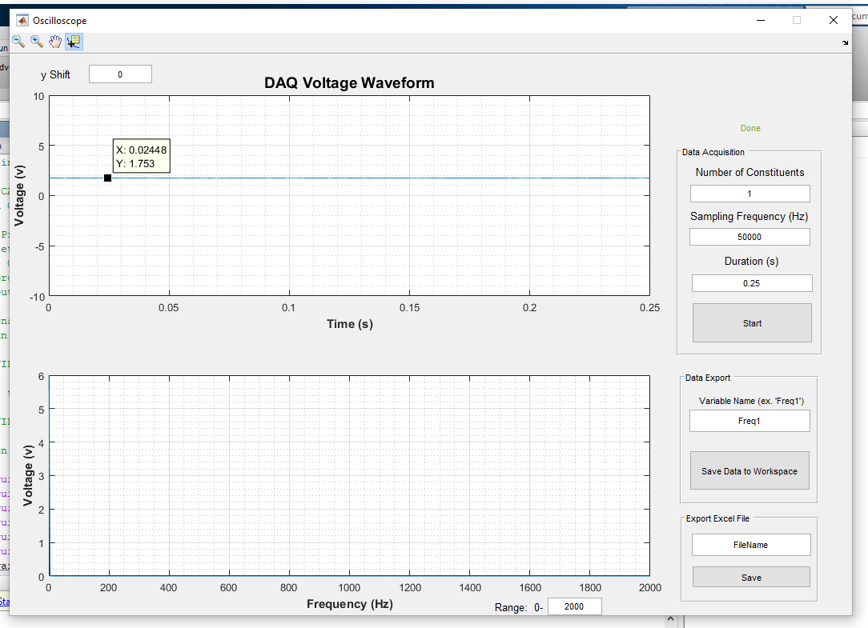

Figure 2

Oscilloscope Matlab script will plot output behavior

Begin the lab by ensuring connections if the hardware is already connected, if not, connect the Oscilloscope, LVDT and computer and ensure that all everything properly turns on. The necessary electrical components necessary for experiment 1 are the LVDT/Beam system, Oscilloscope program and signal filter/connection. After verifying connections, the student will produce a force and allow the beam to oscillate to rest and the oscilloscope matlab program will plot the resulting behavior. The student is to collect the amplitude and individual period between wave peaks.

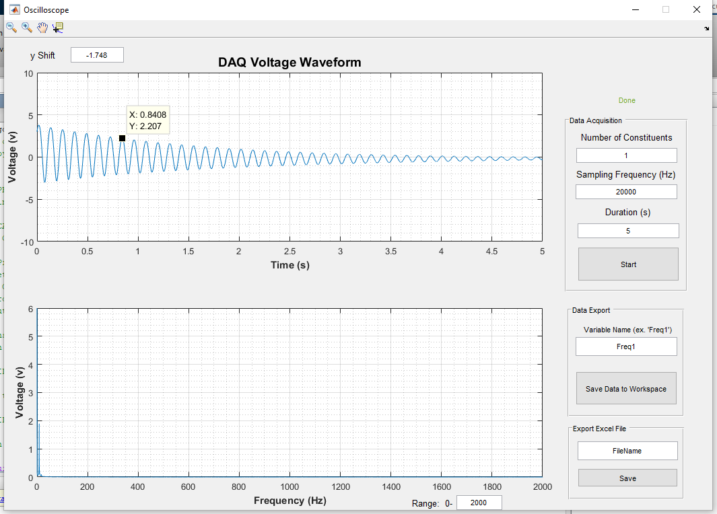

Figure 3

Apply a force and allow the Beam to oscillate freely

After collecting the necessary data, the students may move on to the next experiment, however, completing the first experiment’s post-data collection calculations will provide more insight into the intricacies of experiment 2. In experiment 2, the students will use a signal generator to then plot and analyze a range of frequency inputs and provide further calculations that when coupled with the first experiment’s results, provide access to the system’s inherent properties, mainly the system’s damping coefficient and percent error from a theoretical estimation.

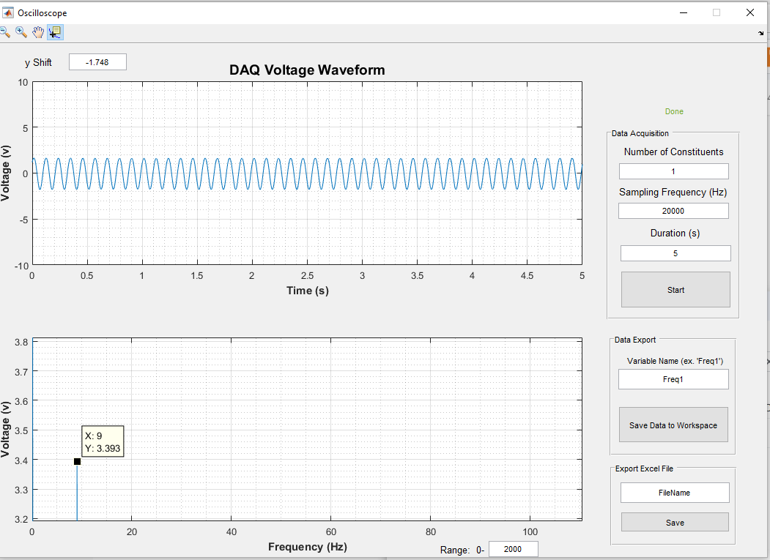

##### 

Figure(s) 4-5

Screenshots from different input frequencies measured by the Oscilloscope program in Matlab

Each frequency will output a spike that the students are expected to collect the amplitude and use as a parameter for future calculations in the data sheet. The intention of experiment 2 was to be used in addition with experiment 1 to understand how one can go about extrapolating inherent parameters in a given system by measuring different properties of a physical system. For systems with less tangible properties to measure, such as electrical systems or microscopic can still, however, be expanded upon in a similar fashion to understand the expected behavior of a system.

## Data Reduction

The following equations are rather self explanatory, however, following the provided data sheet can prove tricky. Specifically, it is difficult to understand the intended use of the Mtheory equation in the experiment 2 section of the data sheet.

The equations guide the student from data input to a resulting parameter from the system. Then, the student is expected to find the percent error for the expected and theoretical calculated magnitude ratio derived from the system’s behavior using the following equations.

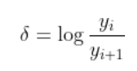

1.

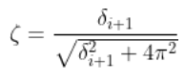

2.



3.

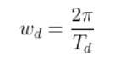

4.

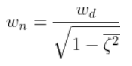

5.

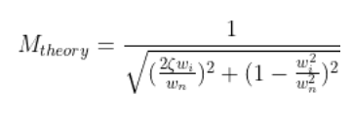

6.

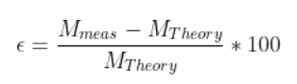

7.

The primary confusion is in the Mtheory equation. The lab data sheet expects more entries than there are elements of zeta. The obvious solution to this is to use the average of zeta calculated previously, however, this will make a constant Mtheory throughout all the iterations.

The first five equations were given in the first equation and help the student derive parameters for the system using logarithmic decrement, then using the data in the second experiment coupled with the findings from the first experiment. As a result, the theoretical and measured magnitude ratios can be found to be .0403 and 15.93 respectively. As mentioned above, there was confusion with calculating the theoretical magnitude ratio and therefore there is a drastically high error associated (99%).

# Results and Discussion

The final results of this experiment are likely skewed due to a misunderstanding of the inputs between experiments for certain equations. Regardless, there is much to learn from utilizing these tools and equations to better understand oscillations and characteristics of different wave frequencies. It is often obvious that the point of each lab is to connect the theory that engineers learn in their core classes and how those equations and methods manifest themselves in real world measurement applications. Furthermore, it is important for an engineer to be able to comprehend and process this data in meaningful ways. For this lab, the student was introduced to extrapolation of data from waveforms that describe it’s inherent behavior and these methods are important in many fields.

As an engineer we are often faced with phenomena we can observe, but not accurately describe without the help of mathematics and instrumentation. If precise enough data can be collected on an observable phenomena, then the engineer is capable of extracting data that can provide intuition to the inner working and expected future behavior of that system. When an engineer is interested in preventing a structure from resonating and it’s natural frequency, it is necessary to know both of these inherent system parameters in order to design against catastrophic failures.

The results extracted from the exact processes detailed in this write-up are flawed. This is due to a repeated issue in this and previous labs on the behalf of the author as an inability to fully comprehend the data reduction and processing expectations and intended directions after the completion of the lab. This makes data processing difficult and the results cloud the true intentions of the lab. This error is minor in the grand scheme of the intuitions that many of the labs and data reductions can provide, however fails to build a complete picture of the relationships that the particular lab relies upon. An error of 99% is, to any sound-minded engineer, likely above the tolerable amount of numerical error. This suggests serious issues with either the system itself, the conduction of the experiment or the mathematical relationships that the engineer is attempting to utilize.

# Conclusion

## The *S*econd Order Systems lab utilized the waveforms produced from a freely oscillating beam when introduced to a singular non-persistent load force. After plotting and gathering data regarding the waveforms amplitude and peak-to-peak period, the student will be able to calculate the average damping coefficient and in addition to the data reduction from the second experiment allow the student to calculate a theoretical and measured magnitude ratio with an associated percent error for each input frequency. The results of this experiment proved an unacceptably high percent error, which in practice, would trigger another iteration of the experiment to explore what could have gone wrong to produce such a high error. The first inclinations to what went wrong show themselves in the data reduction section and require further explanation of the expected methods of calculating some of the necessary components for the final results.

Regardless of the results, the Second Order Systems lab gave a physical insight to what was established in previous labs. Utilizing the oscilloscope to read beam oscillations instead of electrical frequency inputs gives a visual application of the methods shown. These frequencies can still be filtered and manipulated as demonstrated in previous labs and now with the tools detailed in this lab report the student should have an ability to derive information about the system by merely observing different aspects of it’s behavior.

References

1. M. Vanpoppelen, “MABE 345 Lab Report Required Sections.docx” U.S., Knoxville, TN, 2023.
2. V. Aloi. (2023, February). ME/AE/BME 345 Instrumentation and Measurements class notes. [Online]. Available e-mail: valoi@utk.edu

Appendix A: Equipment Information

1. Lab computer (Matlab)
2. LVDT – Beam system
3. Signal filter connection
4. Signal generator



Appendix B: Hand Calculations

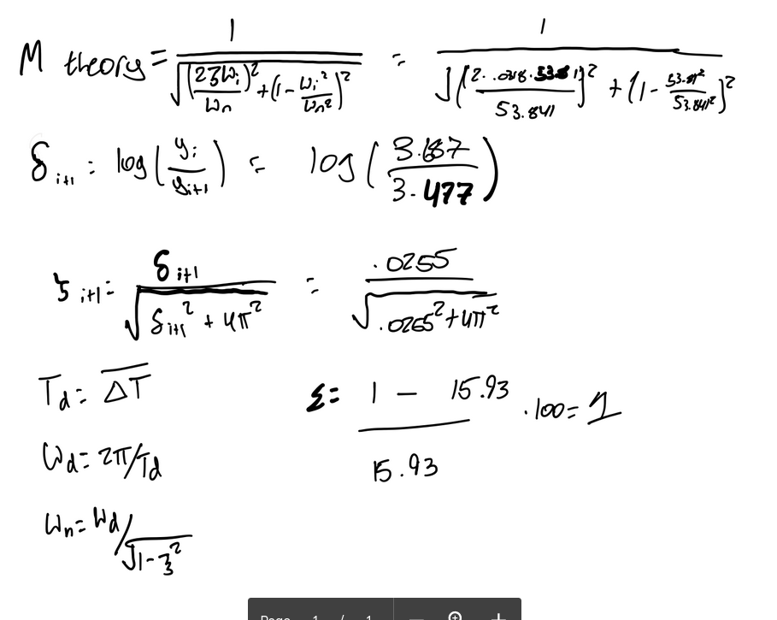

Appendix C: Complete Data Sheet (data continued on hand written sheet)

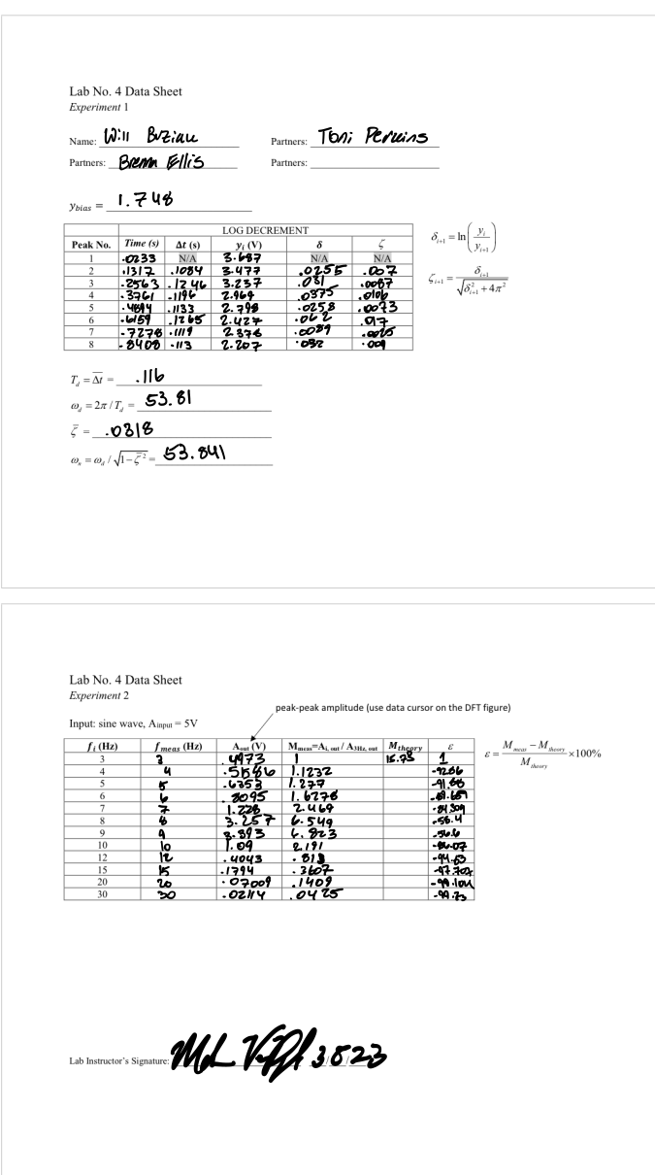

A

Figure C

Experiment 2.

Zero Mass Measurements

Figure F

Instructor Signature